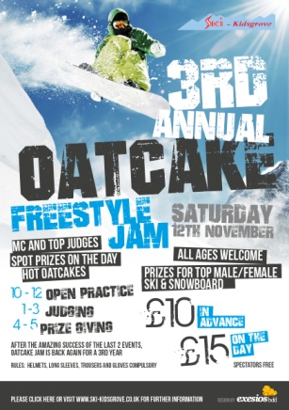
OATCAKE JAM
12th Nov 2016
REGISTRATION FORM
COMPETITORS DETAILS:
Name |  | Date of Birth
Address
Telephone No.

Next of Kin / Emergency Contact Details:
Name
Telephone No.
Relationship

COMPETITION CATEGORIES:

Ski |  | Paypal Transaction ID
Snowboard
 |  | Performing inverted tricks Y/N
Male and Female under 12
Male and Female 12 and over
Paypal Email Address: info@ski-kidsgrove.co.uk

COMPETITION FEES:
* £10 in advance via Paypal / in person at club * £15 on the day of event

IMPORTANT INFO:
- If paying via Paypal, please enter your payment transaction ID in the field above and email the completed form to info@ski-kidsgrove.co.uk.
- Long sleeves, trousers, gloves and helmets must be worn.
- Ski Kidsgrove its officers, employees, members, voluntary helpers and all others associated with this event do not accept liability for injury loss or damage of any kind.
- There will be no refund of entry fees for non attendance.
- You must be trained and assessed in another sport if you wish to perform inverted tricks.

I have read the above and agree to abide by the rules.

Print Name: _______________________________

Signed: _______________________________ Parent or Guardian (if under 18 years of age).

Ski Kidsgrove, Bathpool Park, Kidsgrove,ST7 4EF
T: 01782 784908 E: info@ski-kidsgrove.co.uk

